Laughter is the Best Medicine:
Healing Body, Mind & Spirit

Montgomery Bell State Park
January 25-27, 2019

by and for the Women of
Blakemore U.M.C. and
Clark Memorial U.M.C.
Your Name_____________________________________________________________

Leader in Laughter: Dr. Elizabeth Williams, Professor of Health at TSU and associate pastor at Clark Memorial UMC.

Room Description | # per room | Cost per person
One King Bed | 1 | $269
Two Queen Beds | 2 | $187
Two Queen Beds | 3 | $159
Two Queen Beds | 4 | $146

This cost includes the room, 4 meals, tax and tips.

Please list your phone numbers and email address so that we can contact you with program information and weekend schedule.

Phone:____________________________________________________________________
Email Address: __________________________________________________________

If you need scholarship assistance, please see Deanna McCulley or Kim Goods.

If you have special needs, like handicap access, dietary restrictions, or other medical or physical limitations, please indicate special requests in the space below:

___________________________________________________________________________

____________________________________________________________________________
Reservations & 50% deposit should be submitted by Wednesday, December 19. Make checks payable to Blakemore UMC and bring with this form to Jennifer Meko or the Church office. Funds are nonrefundable after the 20th.

Name of Attendee and roommates | Cost per person
1.
2.
3.
4.

Reduced rate for partial weekend attendance. See Deanna McCulley for details. Deanna.mcculley@gmail.com

Bring cash or credit card if you have an interest in manicures, pedicures or massages during Saturday afternoon.

As part of our mission, we will be collecting travel sized toiletries for Room in the Inn. Please bring some and/or donate what is in your hotel room.

Scriptures: Proverbs 17:22 - A cheerful heart is good medicine, but a downcast spirit dries up the bones.
Psalm 126:2 – Then our mouth was filled with laughter, and our tongue with shouts of joy
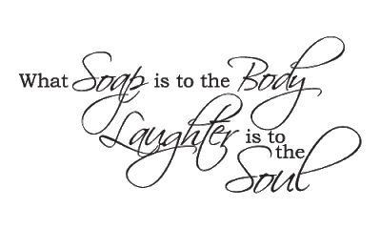

If you have any questions at all please contact:
Jennifer Meko 615-260-7921
jennifermeko@icloud.com

